Robotics & Automation Class

Class Project

1. Project definition

Author: Steve Girah

Data:29.06.2023

Version: V1.0

Project Topic: Using DHT sensor to check temperature and humidity of the environment of a robot.

Objectives: The objectives of this loT & Robotics project is to utilize a DHT sensor to accurately measure and monitor the temperature and humidity levels in the environment surrounding a robot.

By integrating the sensor with the robot’s system, we aim to develop a robust solution that enables real-time data collection, analysis, and appropriate adjustments to optimize the robot’s performance and ensure its operation within specified environmental conditions.

This projects seeks to enhance the robot’s capabilities by providing valuable environmental insights, facilitating efficient decision-making processes, and contributing to overall operational efficiency and reliability.

1. Project design

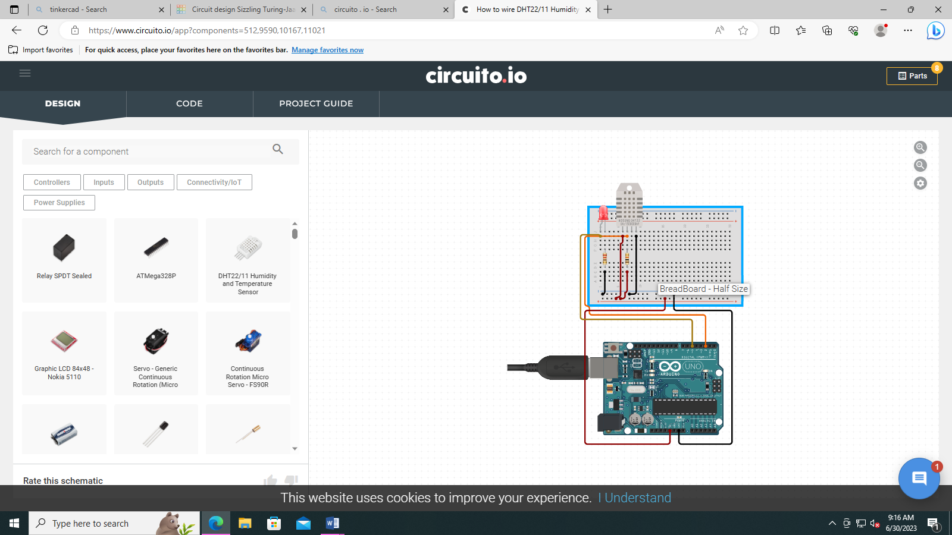

1. Connect the components.
2. Program the microcontroller
3. Observe and report.